# VISVESVARAYA TECHNOLOGICAL UNIVERSITY

## BELAGAVI – 590018, Karnataka INTERNSHIP REPORT

#### ON

“Template for VCT Tea”

***Submitted in partial fulfilment for the award of degree(18CSI85)***

## BACHELOR OF ENGINEERING IN

## YOUR BRANCH

***Submitted by:***

**ANUSHREE**

**KRISHNAMURTHY**

#### 1CD19CS022

#### Conducted at

**VARCONS TECHNOLOGIES PVT LTD**



**CAMBRIDGE INSTITUTE OF TECHNOLOGY Computer Science Engineering**

**Accredited by NBA, New Delhi**

**KR Puram, Bangalore, Karnataka - 560036**

# CAMBRIDGE INSTITUTE OF TECHNOLOGY

**Computer Science Engineering**

**Accredited by NBA, New Delhi**

# KR Puram, Bangalore, Karnataka - 560036



**CERTIFICATE**

This is to certify that the Internship titled **“Template for VCT Tea”** carried out by **Ms. ANUSHREE KRISHNAMURTHY,** a bonafide student of Cambridge Institute of Technology, in partial fulfillment for the award of **Bachelor of Engineering**, in **CSE** under Visvesvaraya Technological University, Belagavi, during the year 2022-2023. It is certified that all corrections/suggestions indicated have been incorporated in the report.

The project report has been approved as it satisfies the academic requirements in respect of Internship prescribed for the course Internship / Professional Practice (18CSI85)

#### Signature of Guide Signature of HOD Signature of Principal

**External Viva:**

Name of the Examiner Signature with Date

1)

2)

# D E C L A R A T I O N

I, **ANUSHREE KRISHNAMURTHY**, final year student of CSE, Cambridge Institute of Technology - 560036, declare that the Internship has been successfully completed, in **Varcons Technologies Pvt Ltd** . This report is submitted in partial fulfillment of the requirements for award of Bachelor Degree in Branch name, during the academic year 2022-2023.

Date :24/09/2022 :

Place : Bengaluru

USN : 1CD19CS022

NAME : ANUSHREE KRISHNAMURTHY

**OFFER LETTER PROVIDED BY THE COMPANY**

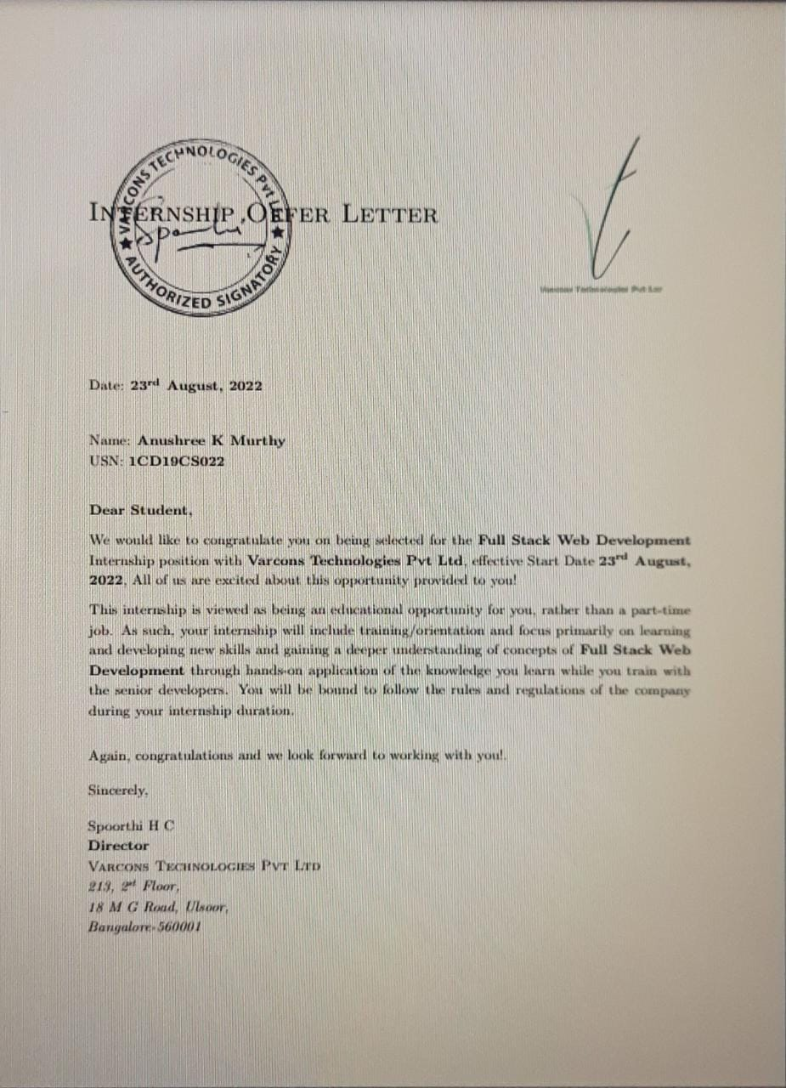

# A C K N O W L E D G E M E N T

This Internship is a result of accumulated guidance, direction and support of several important persons. We take this opportunity to express our gratitude to all who have helped us to complete the Internship.

We express our sincere thanks to our Principal, for providing us adequate facilities to undertake this Internship.

We would like to thank our Head of Dept – branch code, for providing us an opportunity to carry out Internship and for his valuable guidance and support.

We would like to thank our (Lab assistant name) Software Services for guiding us during the period of internship.

We express our deep and profound gratitude to our guide, Guide name, Assistant/Associate Prof, for her keen interest and encouragement at every step in completing the Internship.

We would like to thank all the faculty members of our department for the support extended during the course of Internship.

We would like to thank the non-teaching members of our dept, for helping us during the Internship.

Last but not the least, we would like to thank our parents and friends without whose constant help, the completion of Internship would have not been possible.

**NAME ANUSHREE KRISHNAMURTHY**

**USN 1CD19CS022**

# ABSTRACT

# Tea is one of the most popular drinks due to its pleasant taste and perceived health effects. Although health benefits have been attributed to tea consumption since the beginning of its history, scientific investigation of this beverage and its constituents has been under way for about 30 years. Consumption of tea, in particular green tea (GT), has been correlated with low incidence of chronic pathologies in which oxidative stress has been reported to be involved, such as cancer and cardiovascular diseases.

# The health benefits ascribed to the consumption of teas may be related to the high content of bioactive ingredients such as polyphenols. Polyphenols have been reported to possess antioxidant, antiviral, and anti-inflammatory activities; modulate detoxification enzymes; stimulate immune function and decrease platelet aggregation

# Table of Contents

|  |  |  |
| --- | --- | --- |
| **Sl no** | **Description** | **Page no** |
| 1 | Company Profile | 8 |
| 2 | About the Company | 10 |
| [3](https://1.bp.blogspot.com/-dODuK8N5h1Q/Wlnyb3V9HFI/AAAAAAAACL4/WxQtCJ1pM5wccDABg4wIrTBUB0vlikXQQCLcBGAs/s1600/poly1.jpg) | Introduction | 15 |
| [4](https://1.bp.blogspot.com/-dODuK8N5h1Q/Wlnyb3V9HFI/AAAAAAAACL4/WxQtCJ1pM5wccDABg4wIrTBUB0vlikXQQCLcBGAs/s1600/poly1.jpg) | System Analysis | 18 |
| [5](https://1.bp.blogspot.com/-dODuK8N5h1Q/Wlnyb3V9HFI/AAAAAAAACL4/WxQtCJ1pM5wccDABg4wIrTBUB0vlikXQQCLcBGAs/s1600/poly1.jpg) | Requirement Analysis | 20 |
| 6 | Design [Analysis](https://4.bp.blogspot.com/-IOOxgPaXMVc/Wlj3LWvcnjI/AAAAAAAACKE/UeTFYvAxDmUDel5UBjdifeWaApB3-dXVgCLcBGAs/s1600/img1.jpg) | 22 |
| 7 | [Implementation](https://4.bp.blogspot.com/-IOOxgPaXMVc/Wlj3LWvcnjI/AAAAAAAACKE/UeTFYvAxDmUDel5UBjdifeWaApB3-dXVgCLcBGAs/s1600/img1.jpg) | 24 |
| 8 | Snapshots | 28 |
| 9 | Conclusion | 32 |
| 10 | References | 34 |

[**CHAPTER**](https://1.bp.blogspot.com/-dODuK8N5h1Q/Wlnyb3V9HFI/AAAAAAAACL4/WxQtCJ1pM5wccDABg4wIrTBUB0vlikXQQCLcBGAs/s1600/poly1.jpg) **1** **COMPANY PROFILE**

# COMPANY PROFILE

## A Brief History of Varcons Technologies

Every business is a different and has a unique business model and so are the technological requirements. Varconss Technologies understand this and hence the solutions provided to these requirements are different as well. They focus on clients requirements and provide them with tailor made technological solutions. They also understand that Reach of their Product to its targeted market or the automation of the existing process into e-client and simple process are the key features that our clients desire from Technological Solution they are looking for and these are the features that we focus on while designing the solutions for their clients.

Varconss Technologies is a leading provider of cutting-edge technologies and services, offering scalable solutions for businesses of all sizes. Founded by a group of friends who started by scribbling their ideas on a piece of paper, today they offer smart, innovative services to dozens of clients. They develop SaaS products, provide Corporate Seminars, Industrial trainings and much more.

At VCT, They make sure every product/service that we offer is built keeping in mind the practical usability of the product/Service, they are a startup focused on Creativity and Customizability, and They also provide subscription models for Software that we have already built, Since the application is already configured, the user has a ready-to-use application. This not only reduces installation and configuration time but also cuts down the time wasted on potential glitches linked to software deployment..

They understand that the best desired output can be achieved only by understanding the clients demand better. Varconss Technologies work with their clients and help them todefiine their exact solution requirement. Sometimes even they wonder that they have completely redefined their solution or new application requirement during the brainstormingsession, and here they position themselves as an IT solutions consulting group comprising of high caliber consultants.

They believe that Technology when used properly can help any business to scale and achieve new heights of success. It helps Improve its efficiency, profitability, reliability; to put itin one sentence ” Technology helps you to Delight your Customers” and that is what we want to achieve.

# [CHAPTER](https://1.bp.blogspot.com/-dODuK8N5h1Q/Wlnyb3V9HFI/AAAAAAAACL4/WxQtCJ1pM5wccDABg4wIrTBUB0vlikXQQCLcBGAs/s1600/poly1.jpg) 2 ABOUT THE COMPANY

1. **ABOUT THE COMPANY**



Varconss Technologies is a leading provider of cutting-edge technologies and services, offering scalable solutions for businesses of all sizes. Founded by a group of friends who started by scribbling their ideas on a piece of paper, today they offer smart, innovative services to dozens of clients. They develop SaaS products, provide Corporate Seminars, Industrial trainings and much more. The organization where they have a right mix of professionals as a stakeholders to help us serve our clients with best of our capability and with at par industry standards. They have young, enthusiastic, passionate and creative Professionals to develop technological innovations At VCT, they make sure every product/service that we offer is built keeping in mind the practical usability of the product/Service, We're a startup focused on Creativity and Customizability, and they also provide subscription models for Software that we have already built, Since the application is already configured, the user has a ready-to-use application. This not only reduces installation and configuration time but also cuts down the time wasted on potential glitches linked to software deployment.

### Products of Varconss Technologies.

###### Smart Automation Tools

Smart Automation combines a deep understanding of workflow with robust granular data to allow highly efficient, accurate, and controlled decisions to be made. For example, “Automation” is represented by the standard cruise control that maintains a car’s speed. Alternatively, “Smart Automation” is the autopilot or enhanced cruise control systems that use cameras, radar and sonar to read and understand the immediate environment.

###### Search Engine Optimisation

SEO stands for “search engine optimization.” In simple terms, it means the process of improving your site to increase its visibility when people search for products or services related to your business in Google, Bing, and other search engines. The better visibility your pages have in search results, the more likely you are to garner attention and attract prospective and existing customers to your business.

Search engines such as Google and Bing use bots to crawl pages on the web, going from site to site, collecting information about those pages and putting them in an index. Think of the index like a giant library where a librarian can pull up a book (or a web page) to help you find exactly what you’re looking for at the time.

Next, algorithms analyze pages in the index, taking into account hundreds of ranking factors or

signals, to determine the order pages should appear in the search results for a given query. In our library analogy, the librarian has read every single book in the library and can tell you exactly which one will have the answers to your questions.

Analytics and Research

They analyse the way your users/customers interact with you/your business by gathering, studying and understanding the consumer voice and their perception of the product/service

The Research & Analytics (R&A) is a smart blend of domain knowledge in Market Research and Analytics in conjunction with the core Technology forte of The key focus remains around deriving insights from structured and unstructured data using AI/ML, Data Management, Knowledge portals, Analytical Methodologies, Consulting and Story Telling to meet the end objectives of Brands & Agencies. This is further fueled by agile & intuitive layers of Business Intelligence and Data Visualization for faster decision making. We also provide support for Speech to Text Analytics, Mystery Audits, Data Collection, Preparation and Integration.

Branding and Design

They offer professional Graphic design, Brochure design & Logo design. They are experts in crafting visual content to convey the right message to the customers. They also design custom wraps for your products(also known as package designing).

Website as Software

They develop websites that behave and interact similar to sophisticated software.

Comprehensive Customer Support

With a comprehensive range of services, they guarantee your technology needs are not just met, but exceeded. They shall work with your customers/users closely to understand the way your users/customers use/make use of products/services

Embedded Systems and IOT

They work with Consumer Electronics, Lighting, Home Automation, Metering, Sensor- Technology, Home Appliance and Medical Device companies to help them create smart and connected products. Through its integrated Embedded and IoT services, VCA helps build intelligent & connected devices that can be remotely monitored and controlled while leveraging edge and cloud computing for a host of intelligent applications and analytics.

**Web design**

It is encompasses many different skills and disciplines in the production and maintenance of websites. The different areas of web design include web graphic design; interface design; authoring, including standardized code and proprietary software; user experience design; and

search engine optimization. The term web design is normally used to describe the design process relating to the front-end (client side) design of a website including writing mark up. Web design partially overlaps web engineering in the broader scope of web development. Web designers are expected to have an awareness of usability and if their role involves creating mark up then they are also expected to be up to date with web accessibility guidelines. Web design partially overlaps web engineering in the broader scope of web development.

## Departments and services offered

Varcons Technologies plays an essential role as an institute, the level of education, development of student’s skills are based on their trainers. If you do not have a good mentor then you may lag in many things from others and that is why we at Varcons Technologies gives you the facility of skilled employees so that you do not feel unsecured about the academics. Personality development and academic status are some of those things which lie on mentor’s hands. If you are trained well then you can do well in your future and knowing its importance of Compsoft Technologies always tries to give you the best.

They have a great team of skilled mentors who are always ready to direct their trainees in the best possible way they can and to ensure the skills of mentors we held many skill development programs as well so that each and every mentor can develop their own skills with the demands of the companies so that they can prepare a complete packaged trainee.

## Services provided by Varcons Technologies.

* Core Java and Advanced Java
* Web services and development
* Dot Net Framework
* Python
* Selenium Testing
* Conference / Event Management Service
* Academic Project Guidance
* On The Job Training
* Software Training

# [CHAPTER](https://1.bp.blogspot.com/-dODuK8N5h1Q/Wlnyb3V9HFI/AAAAAAAACL4/WxQtCJ1pM5wccDABg4wIrTBUB0vlikXQQCLcBGAs/s1600/poly1.jpg) 3 INTRODUCTION

1. **INTRODUCTION**

## Introduction to Web Apps

Web applications are similar to the traditional applications you’d install on your Information, such as Microsoft Office. They are able to perform the same kinds of tasks, they look the same and they feel the same but there is one key difference - the application itself is not installed on your phone or Information, but lives in the cloud. Web apps are not new, but it used to be that they were often unable to compete with more traditional applications for business critical functions or where rich user interaction was required. This is no longer the case. With the power of modern web technologies, we are able to design and build performing, secure, and feature rich applications that live in the cloud and bring with them a huge number of benefits.

#### They can be accessed from anywhere.

* Because web applications are built with web technologies and they run in a web browser Internet Explorer, Google Chrome, Mozilla Firefox – this allows them to be accessed from every web enabled tool. As long as you have an internet connection you can use them.
* It allows for remote working, it allows for rapid publishing of content, it allows for real time collaboration between teams. If you have web access, you have the ability to access your business tools.

#### They are cost effective.

* Web applications are cheaper to produce and maintain than traditional applications. No matter how many platforms your business uses (Mac, Linux, Windows) web application build can be used across them all.

#### They benefit from more rapid update cycles.

* A huge benefit of web applications is that when an update is released, all of your users are immediately using that version. This doesn’t happen with installed applications, especially in large organizations with IT policies that restrict administrator access.

#### They are secure.

* Web developers have had to become experts in security – the web is a platform designed to share everything with everyone! As such, the types and levels of security included in web applications are often far greater than those seen in traditional applications.
* They also benefit from the ability to launch updates in real-time – the application on the servers is the application people are using. The applications on people’s laptops however is the version last installed. And when those laptops get left on a train it’s not a concern, as nothing is stored locally.

#### They enable more computing with fewer Information.

* Web applications push all of the hard work to the servers, and act as intermediaries between the user interface and the calculations happening behind the scenes. This means you can accomplish terrifyingly complex work on a tablet, or your phone.
* We’ve built web applications that allow people to understand the complex relationships between 250,000 pieces of art on their phones, and applications that run the business systems of one of the largest solar energy providers in the world. Often these products are not financially viable to build using traditional application processes.

## Problem Statement

Develop an application which facilitates creation of web pages having a need to install any HTML editor based software and also which can be used by any novice user (no HTML knowledge needed) that is developing web pages on the online. This module is designed to reduce the process involved in managing the activity of customers and business where the business can sell their services and the customers can buy those.

## Introduction to B2C Ecommerce Website Development with Admin Panel

B2C E-commerce website content providers to focus on creating effective assessment questions and focusing on providing a platform for easy access between Buyer and Consumer.

Here we present techniques that are pertinent to the elements of assessment process: answers submission, Informationized grading, and feedback after submission. As the modern organizations are automated and Information are working as per the instructions, it becomes essential for the coordination of human beings, commodity and information in a modern organization.

# [CHAPTER](https://1.bp.blogspot.com/-dODuK8N5h1Q/Wlnyb3V9HFI/AAAAAAAACL4/WxQtCJ1pM5wccDABg4wIrTBUB0vlikXQQCLcBGAs/s1600/poly1.jpg) 4 SYSTEM ANALYSIS

**4. SYSTEM ANALYSIS**

## Existing System

## 

## Proposed System: The signup page launches initially when the project is run . The user can create a login entry by providing basic details with the help of authentication facilities a user is identified uniquely through his username and password. Later one can use various features like calorie intake ,day wise workout list and also achievements and goals can be noted

## Objective of the System: Allow a one to one communication which is personal to each user.

# [CHAPTER](https://1.bp.blogspot.com/-dODuK8N5h1Q/Wlnyb3V9HFI/AAAAAAAACL4/WxQtCJ1pM5wccDABg4wIrTBUB0vlikXQQCLcBGAs/s1600/poly1.jpg) 5 REQUIREMENT ANALYSIS

**5. REQUIREMENT ANALYSIS**

## Hardware Requirement Specification

* + MySQL
  + NODE JS
  + Notepad++ Editor
  + Processor: Intel core i5 processer
  + Memory: 15.6 GB
  + Hard Disk: 40 GB

## Software Requirement Specification

### Functional Requirements

* + Django framework
  + Python version 3.6 or higher
  + PILLOW installation
  + Django crispy forms framework
  + Django social auth app installation

### Non-Functional Requirements

#### Availability

The online registration system shall permit backing up of the registration database while other registration actives are going on.

#### Accessibility

The system shall be accessible by people with specific vision needs to the extent that a user shall be able to display whole user interface in a larger font without truncating displayed text or other values.

#### Security

The access permissions for system data may only be change by the systems data administrator passwords shall never be viewable at the point of entry or any other time.

# [CHAPTER](https://1.bp.blogspot.com/-dODuK8N5h1Q/Wlnyb3V9HFI/AAAAAAAACL4/WxQtCJ1pM5wccDABg4wIrTBUB0vlikXQQCLcBGAs/s1600/poly1.jpg) 6

# DESIGN ANALYSIS

1. **DESIGN & ANALYSIS**

**6.1 UML DIAGRAM**

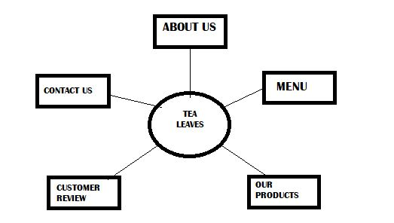

# [CHAPTE](https://1.bp.blogspot.com/-dODuK8N5h1Q/Wlnyb3V9HFI/AAAAAAAACL4/WxQtCJ1pM5wccDABg4wIrTBUB0vlikXQQCLcBGAs/s1600/poly1.jpg)R 7

# IMPLEMENTATION

1. **IMPLEMENTATION**

Implementation is the stage where the theoretical design is turned into a working system. The most crucial stage in achieving a new successful system and in giving confidence on the new system for the users that it will work efficiently and effectively.

The system can be implemented only after thorough testing is done and if it is found to work according to the specification. It involves careful planning, investigation of the current system and it constraints on implementation, design of methods to achieve the change over and an evaluation of change over methods a part from planning.

Two major tasks of preparing the implementation are education and training of the users and testing of the system. The more complex the system being implemented, the more involved will be the system analysis and design effort required just for implementation.

The implementation phase comprises of several activities. The required hardware and software acquisition is carried out. The system may require some software to be developed. For this, programs are written and tested. The user then changes over to his new fully tested system and the old system is discontinued.

**Links calling other CSS file**

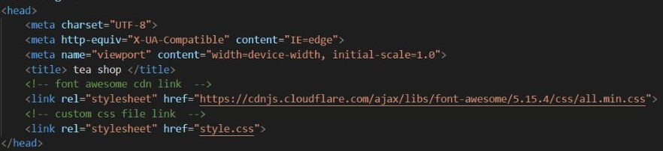

**Section header**

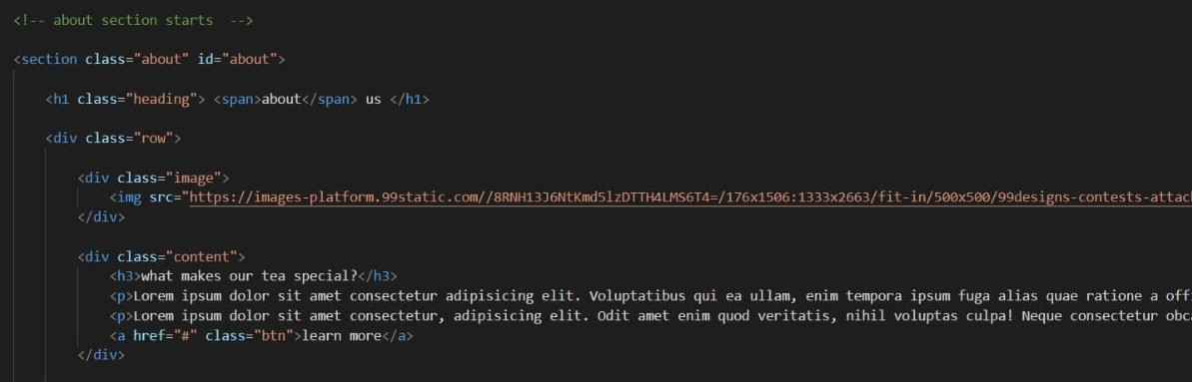

## Script CSS

## 

## Style CSS

## 

## TESTING

The testing phase is an important part of software development. It is the Information zed system will help in automate process of finding errors and missing operations and also a complete verification to determine whether the objectives are met and the user requirements are satisfied. Software testing is carried out in three steps:

1. The first includes unit testing, where in each module is tested to provide its correctness, validity and also determine any missing operations and to verify whether the objectives have been met. Errors are noted down and corrected immediately.
2. Unit testing is the important and major part of the project. So errors are rectified easily in particular module and program clarity is increased. In this project entire system is divided into several modules and is developed individually. So unit testing is conducted to individual modules.
3. The second step includes Integration testing. It need not be the case, the software whose modules when run individually and showing perfect results, will also show perfect results when run as a whole.

# 

# [CHAPTE](https://1.bp.blogspot.com/-dODuK8N5h1Q/Wlnyb3V9HFI/AAAAAAAACL4/WxQtCJ1pM5wccDABg4wIrTBUB0vlikXQQCLcBGAs/s1600/poly1.jpg)R 8

# SNAPSHOTS

* 1. **SNAPSHOTS**



**FIG 8.1: Front Page**



**FIG 8.2: About Us**

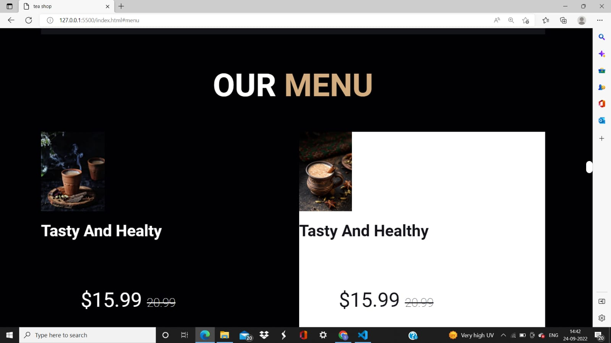

**FIG 8.3: Our Menu**

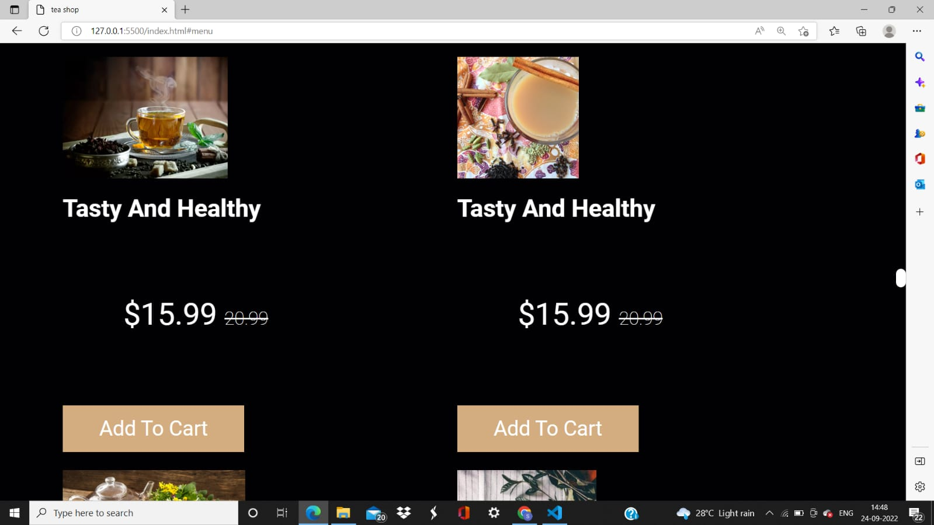

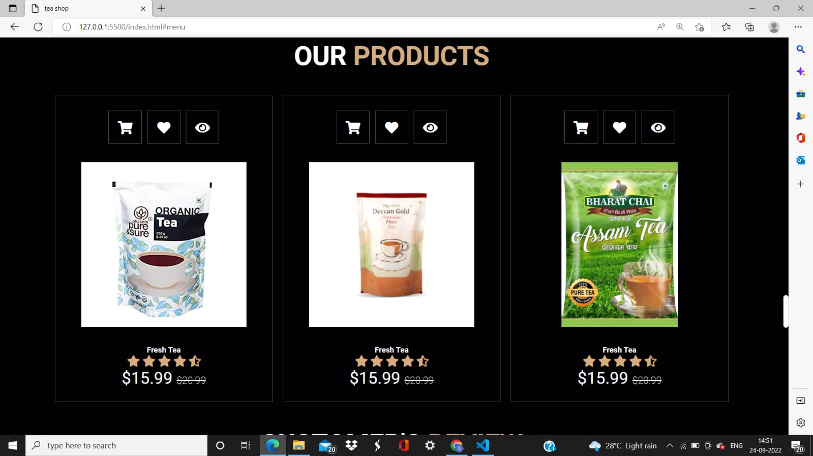

**FIG 8.4: Our Products**

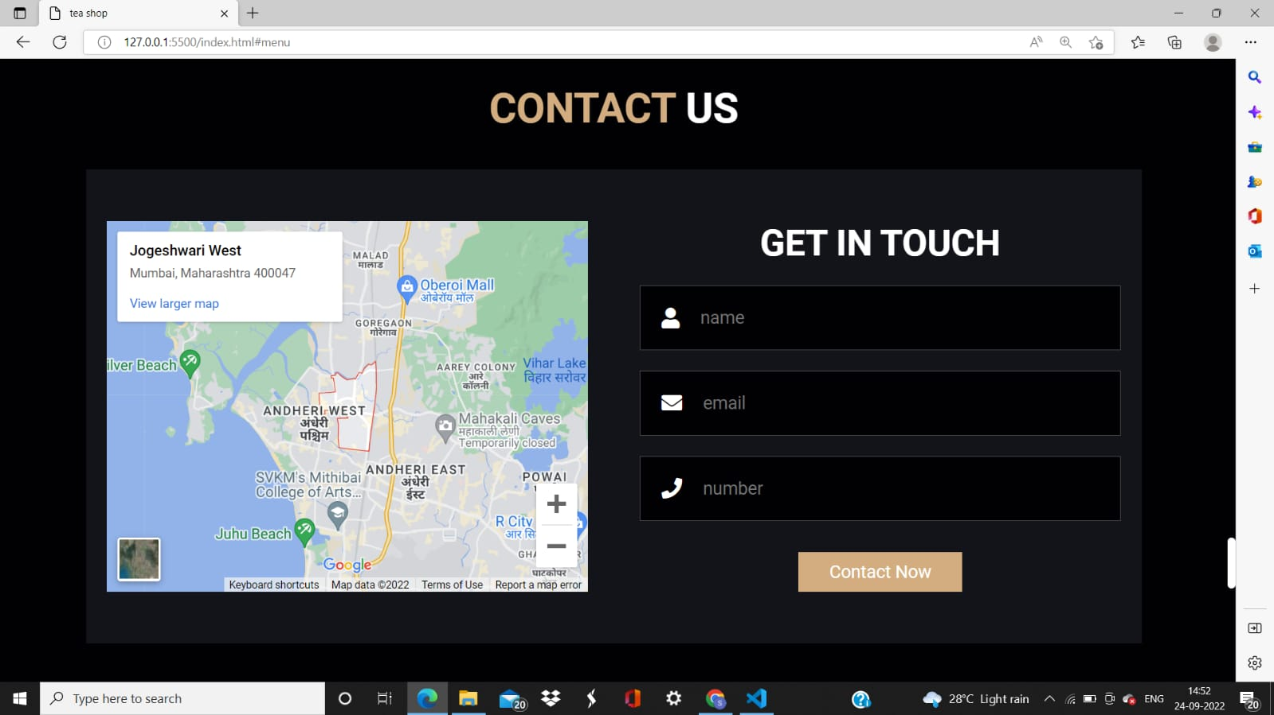

**FIG 8.5: Contact Us**

# [CHAPTE](https://1.bp.blogspot.com/-dODuK8N5h1Q/Wlnyb3V9HFI/AAAAAAAACL4/WxQtCJ1pM5wccDABg4wIrTBUB0vlikXQQCLcBGAs/s1600/poly1.jpg)R 9

# CONCLUSION

* 1. **CONCLUSION**

The package was designed in such a way that future modifications can be done easily. The following conclusions can be deduced from the development of the project:

* Automation of the entire system improves the efficiency
* It provides a friendly graphical user interface which proves to be better when compared to the existing system.
* It gives appropriate access to the authorized users depending on their permissions.
* It effectively overcomes the delay in communications.
* Updating of information becomes so easier
* System security, data security and reliability are the striking features.
* The System has adequate scope for modification in future if it is necessary.

# REFERENCE

* <https://youtu.be/GeykycZ4Ixs>
* <https://youtu.be/P8YuWEkTeuE>
* [www.w3schools.com/whatis/whatis_fullstack.asp](http://www.w3schools.com/whatis/whatis_fullstack.asp)
* w3schools.com/bootstrap/
* getbootstrap.com/